INNOVA JUNIOR COLLEGE
JC 2 PRELIMINARY EXAMINATION 2
in preparation for General Certificate of Education Advanced Level
Higher 1

CANDIDATE
NAME

CLASS INDEX NUMBER

BIOLOGY  Paper 1 Multiple Choice  Additional Materials: Multiple Choice Answer Sheet | 8875/01  22 September 2010  1 hour

READ THESE INSTRUCTIONS FIRST

Write your name and class on all the work you hand in.
Write in soft pencil.
Do not use staples, paper clips, highlighters, glue or correction fluid.

There are thirty questions on this paper. Answer all questions. For each question there are four possible answers A, B, C and D.
Choose the one you consider correct and record your choice in soft pencil on the separate Answer Sheet.

Read the instructions on the Answer Sheet very carefully.

Each correct answer will score one mark. A mark will not be deducted for a wrong answer.
Any rough working should be done in this booklet.
Calculators may be used.

This document consists of 12 printed pages.
 | Innova Junior College | [Turn over

1 | Which description of the characteristics of prokaryotic and eukaryotic cells is correct?
   | prokaryotic cells | eukaryotic cells
   | absence of mitochondria, can only undergo anaerobic respiration | mitochondria present, undergoes aerobic or anaerobic respiration
   | absence of ribosomes | presence of membrane-bound organelles
   | unicellular | multiple cellular
   | circular DNA | linear DNA
2 | A piece of mammalian tissue was homogenised and subjected to differential centrifugation to yield four subcellular fractions. The activity within each fraction, of four different types of enzyme, A, B, C and D was investigated.  Which bar chart shows the results of investigating hydrolytic enzyme activity?  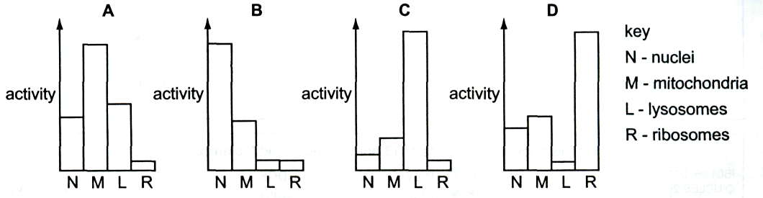
3 | At which levels of protein structure do hydrophobic interactions occur?  - primary, secondary and tertiary  - secondary, tertiary and quaternary  - tertiary and quaternary  - quaternary only
4 | The diagram below shows part of a macromolecule  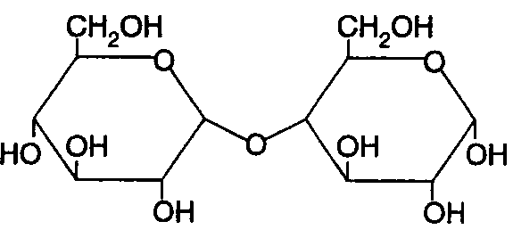  X  The bond labelled X is the  - ester bond  - glycosidic bond  - hydrogen bond  - peptide bond
5 | Some germinating seeds are crushed with water and the extract is tested. The table shows the results of these tests.  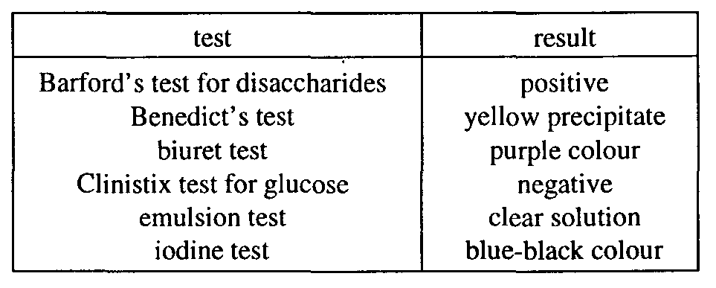  Which molecules are present in the extract?  - fat, maltose, starch only  - fat, protein, sucrose only  - glucose, protein, starch only  - maltose, protein, starch only
6 | The diagram shows part of a cell membrane.  The structure(s) that allows hydrophobic molecules to pass through is/are  - 1 only  - 4 only  - 1 and 2  - 2 and 3
7 | The graph shows the effect of an enzyme on a reaction.  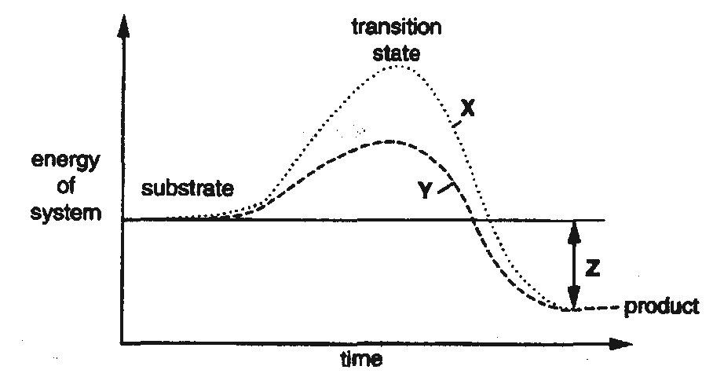  Which combination identifies X, Y and Z?
   | X | Y | Z
   | catalysed reaction | uncatalysed reaction | activation energy
   | catalysed reaction | uncatalysed reaction | energy lost during reaction
   | uncatalysed reaction | catalysed reaction | energy lost by product
   | uncatalysed reaction | catalysed reaction | overall energy change
8 | A culture of bacteria produces the food supplement lysine by the metabolic pathway shown.  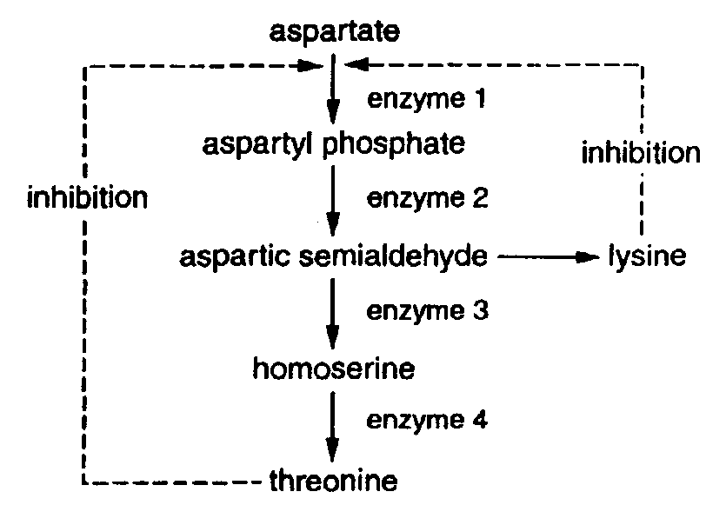  Which change in enzyme activity will result in the greatest increase in lysine yield?  Which combination identifies X, Y and Z?
   | enzyme | change in activity
   | 1 | decrease
   | 2 | increase
   | 3 | increase
   | 4 | decrease
9 | Human cells contain 46 chromosomes. The diagram shows a human cell in prophase of mitosis (cell 1) and the daughter cells just after telophase (cell 2 and cell 3).  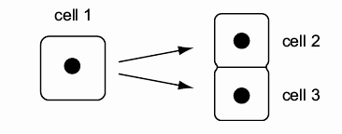  How many DNA molecules are there in the nucleus of cell 1 and cell 2?  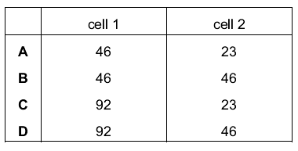
10 | The presence of starch in maize pollen grains is controlled by a pair of alleles at a single gene locus. One allele codes for the presence while the other allele results in the absence of starch. Half of the pollen grains of a heterozygous maize plant are found to contain starch. This is because  - half the pollen are heterozygous while the other half homozygous.  - the alleles are codominant to each other.  - the alleles separate at meiosis during anaphase I and II.  - the genes interact with each other.
11 | The diagram represents an anticodon.  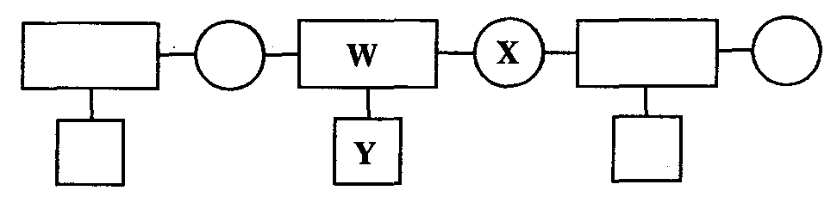  What do W, X and Y represent?  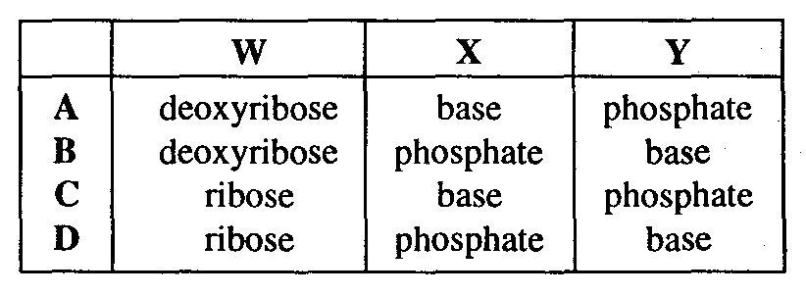
12 | How many different polypeptides, each consisting of r amino acids, can be made if the number of different amino acids available is n?  - n^{r}  - r^{n}  - nr  - n
13 | The table shows the percentages of nitrogenous bases in four samples of nucleic acids. Which base is adenine?  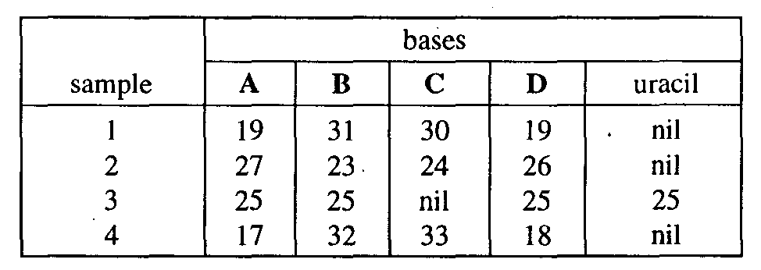
14 | Bacteria grown in ¹⁵N for many generations were transferred to ¹⁴N for further replication. DNA from the bacteria was extracted and separated by density gradient centrifugation.  Their results are summarised in the following diagram.  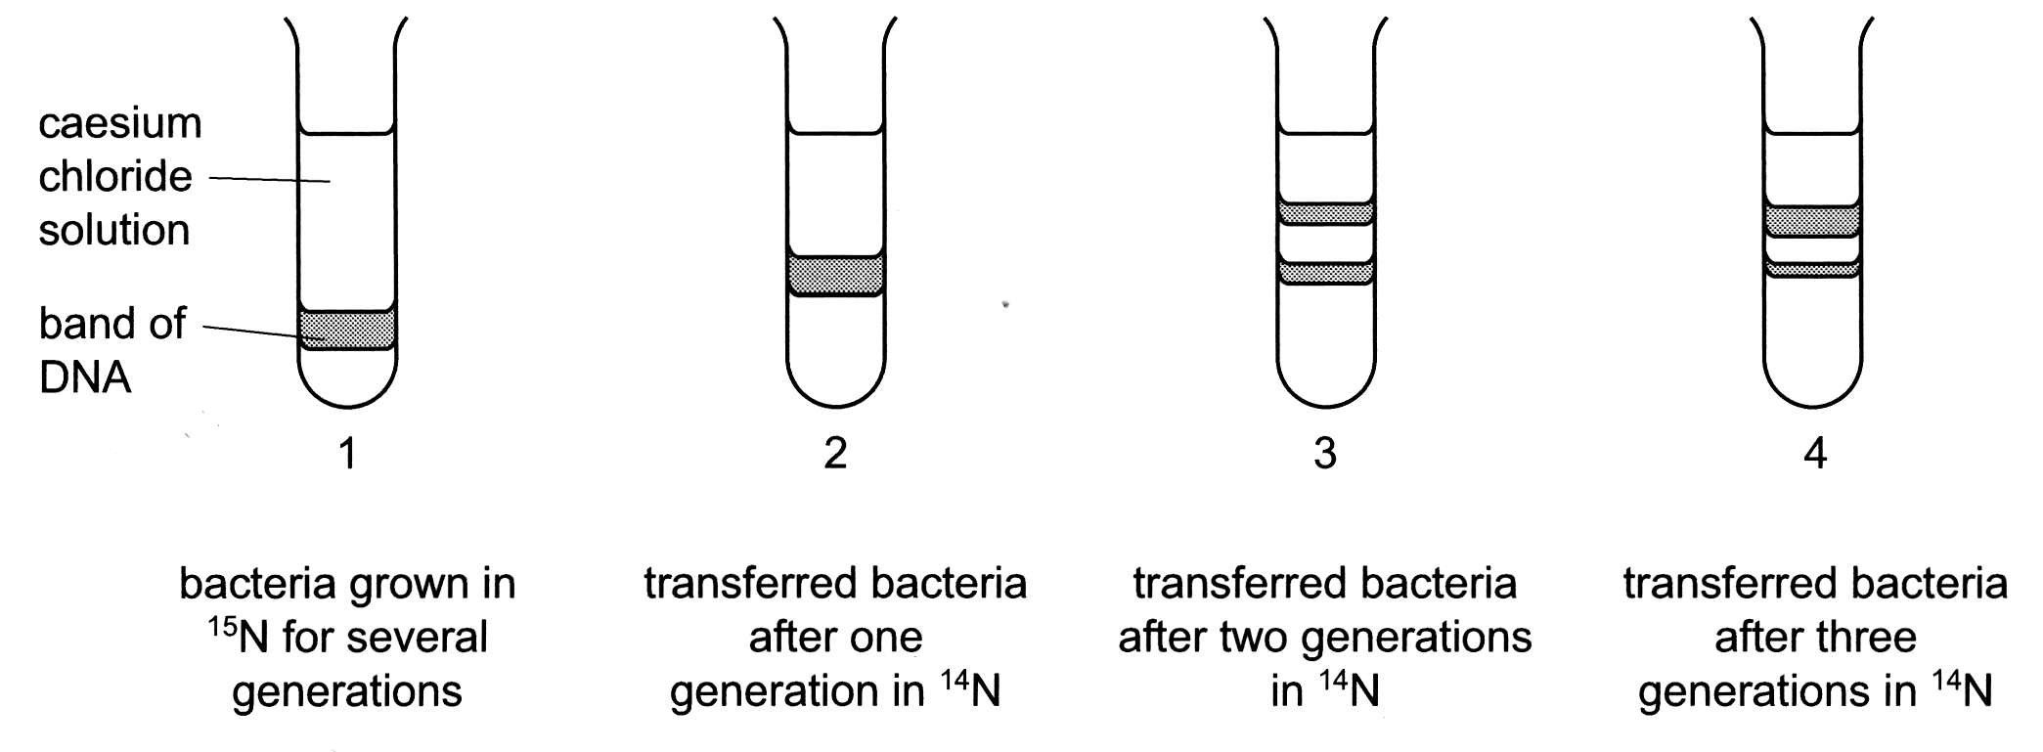  What are the percentages of DNA containing ¹⁵N and ¹⁴N in tube 4?  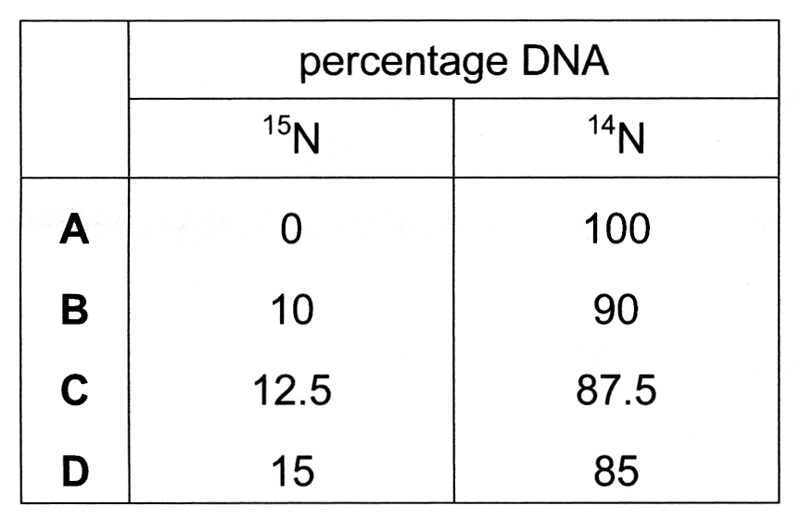
15 | A mutation of a gene coding for an ion pump in cell surface membranes results in the substitution of one amino acid, arginine, by another, histidine.  The DNA triplet codes for the two amino acids are shown.  arginine GCA histidine GTA  GCG GTG  GCT  GCC  TCT  TCC  Which mutation has occurred in the DNA?  - Addition of an extra nucleotide.  - Replacement of a nucleotide with a purine base by one with a different purine base.  - Replacement of a nucleotide with a purine base by one with a pyrimidine base.  - Replacement of a nucleotide with a pyrimidine base by one with a different pyrimidine base.
16 | Some people are genetically predisposed to suffer from particular diseases. The table shows some diseases and their causes.  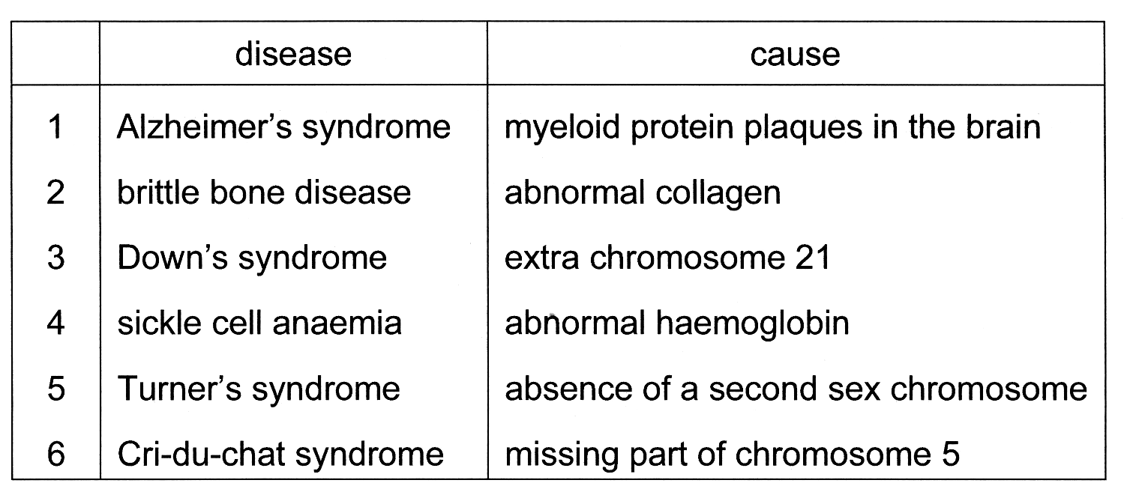  Which diseases are caused by gene mutation and which by chromosome aberration?  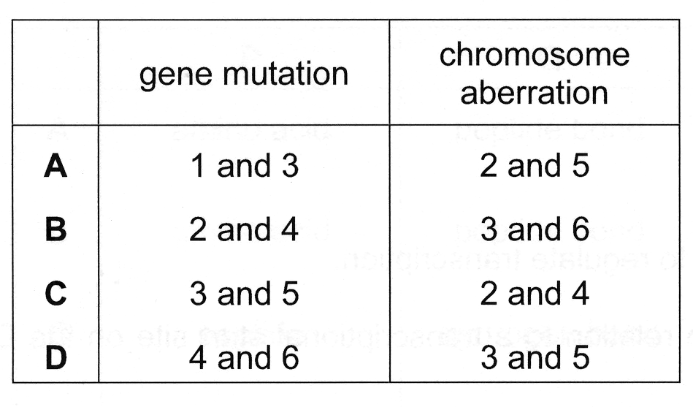
17 | The processing of pre-mRNA involves the following steps to produce functional mRNA.  1 polyadenylation  2 removal of introns  3 splicing of exons  4 capping  In which order do they occur?  - 1  3  2  4  - 2  4  1  3  - 3  1  4  2  - 4  2  3  1
18 | Which of the following is an example of a possible step in the post-transcriptional control of gene expression?  - Gene amplification during a stage in development.  - The addition of methyl groups to cytosine bases of DNA.  - The binding of transcription factors to a promoter.  - The removal of introns and splicing together of exons.
19 | A tall, pink-flowered plant is self-fertilised and produces the offspring shown.  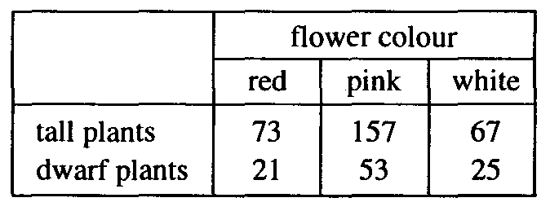  When self-fertilised, which type of plant will only produce identical offspring?  - dwarf, pink-flowered  - dwarf, white-flowered  - tall, red-flowered  - tall, white-flowered
20 | In maize plants, two gene loci on different chromosomes have the following alleles.  Gene locus one Gene locus two  R : green stems D : normal height  r : red stems d : dwarf plants  The following cross between 2 heterozygotes produced 1600 seeds which were collected and counted. It would be reasonable to expect that among the offspring, approximately  - 100 offspring would be homozygous at both gene loci.  - 600 of the offspring will have green stems and be of normal height.  - ⅔ of the green stem, dwarf offspring will be heterozygous at gene locus one.  - ⅓ of the red stem, normal height offspring will be heterozygous at both gene loci.
21 | The diagram shows the inheritance of haemophilia in a family.  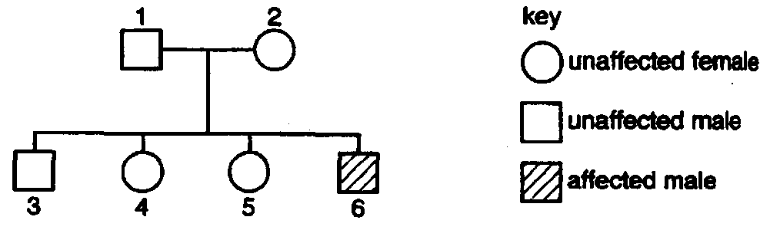  If daughter 4 married a normal male, what is the probability that their first child would suffer from haemophilia?  - 0  - 0.125  - 0.25  - 0.5
22 | Which of the following process is the link between the light dependent and the light independent stages of photosynthesis?  - Photolysis of water  - Photoactivation of reaction centre  - Production of RuBP  - Production of NADPH and ATP
23 | The diagram represents a section through a chloroplast.  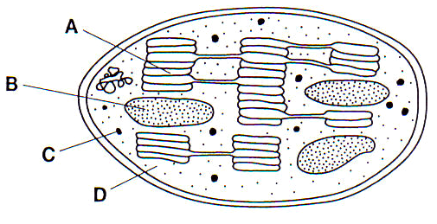  In which part does chemiosmosis takes place?
24 | Four test-tubes were set up as shown.  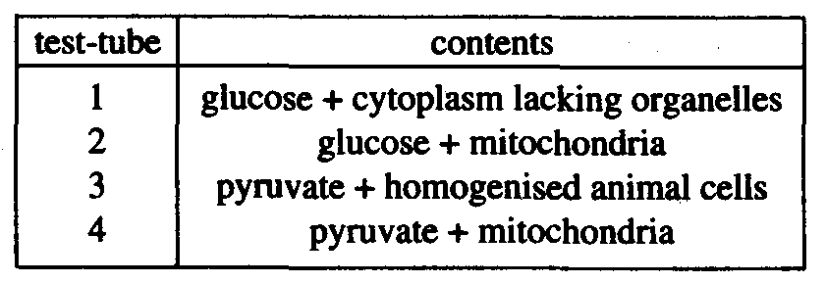  After incubation, each sample was analysed to determine the presence of lactate. In which test-tube is lactate most likely to be present?  - 1  - 2  - 3  - 4
25 | Which one of the following statements about natural selection is incorrect?  Natural selection may  - cause new genes to appear in a gene pool.  - occur in stable environmental conditions.  - result in an increase in the frequency of favourable genes in a gene pool.  - result in an increase in the percentage of well-adapted individuals in a population.
26 | DNA-DNA hybridisation is a technique used to determine the similarity of DNA from different species.  In this technique:  - DNA is extracted from different species and cut into pieces using special enzymes;  - the DNA is heated to separate the double strands into single strands;  - single strands of DNA from different species are mixed together and cooled so that double strands of hybrid DNA form.  The following table shows the temperature (°C) needed to separate the hybrid DNA strands of four different species, Q, R, S, and T:  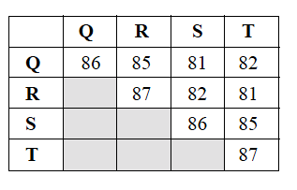  Which one of the following statements is supported by the data provided?  - Q is more closely related to R than S is to T.  - Q is more closely related to S than it is to R or T.  - S is more closely related to R than Q is to T.  - S is more closely related to T than it is to R or Q.
27 | Which of the following shows the correct sequence of events for producing human growth hormone (hGH) using the bacterium E. coli?
 | 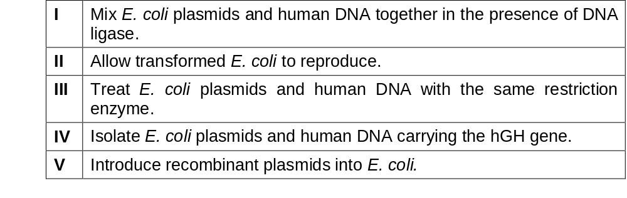
- IV, I, III, V, II
- IV, III, I, V, II
- IV, III, V, I, II
- V, IV, I, III, II

28 | In genetic engineering of bacteria to produce insulin, what was the vector?  - bacterium  - target gene  - restriction enzyme  - plasmid
29 | The completion of the Human Genome Project revealed that the human genome contains fewer genes than expected, not so many more than simpler organisms. Which of the following statements could explain this phenomenon?  - RNA transcripts of human genes are more likely to undergo alternative splicing.  - Polypeptide domains are combined in a variety of ways.  - Post-translational processing adds diversity to the resulting polypeptides.  - Gene expression patterns in humans are often more complex than those in other organisms.
- 1 only
- 1 and 2
- 2, 3 and 4
- 1, 2, 3 and 4

30 | Embryonic stem cells offer great promise to the cure of many diseases because  i they are pluripotent.  ii they are more readily available than other cells.  iii they can be easily cultured in vitro.  iv they will differentiate and produce cells which are normal.  Which of the following is/are true?  - i, iv  - ii, iii, iv  - i, iii, iv  - iv only

2010 JC2 Prelim Exam II
H1 Biology Paper 1

Qn | Answer | Qn | Answer | Qn | Answer
1 | D | 11 | D | 21 | B
2 | C | 12 | A | 22 | D
3 | C | 13 | B | 23 | A
4 | B | 14 | C | 24 | A
5 | D | 15 | D | 25 | A
6 | A | 16 | B | 26 | D
7 | D | 17 | D | 27 | B
8 | D | 18 | D | 28 | D
9 | D | 19 | B | 29 | D
10 | C | 20 | A | 30 | A

